🧬 COVID-19 Clinical Trials Exploratory Data Analysis

📊 Project Overview
This project provides an in-depth Exploratory Data Analysis (EDA) of global COVID-19 clinical trials.
Using data cleaning, transformation, and visualization techniques in Python, the analysis explores trends in trial phases, statuses, conditions, interventions, enrollments, and timelines.
🧠 Objectives
- Understand the distribution of clinical trials by phase, status, and country
- Identify the most common conditions and interventions studied
- Examine enrollment patterns and trial durations
- Track the temporal trend of trial initiations
- Provide a cleaned and standardized dataset for downstream analysis or dashboarding
🧹 Data Cleaning & Preparation
- Removed duplicates based on trial ID and title
- Standardized phase and status fields
- Normalized multi-value columns (split countries, interventions, conditions)
- Converted date fields and calculated trial duration (days)
- Handled missing and inconsistent enrollments
- Created a refined dataset ready for analysis

Executive Summary
This project presents an exploratory data analysis (EDA) of global COVID-19 clinical trial data. The goal is to understand research trends, intervention types, study statuses, and global participation during the pandemic. Using Python (Pandas, Matplotlib, Seaborn), the dataset was cleaned and analyzed to derive insights into how the world responded to the COVID-19 health crisis through clinical studies.
Project Overview & Objectives
The COVID-19 Clinical Trials EDA project investigates patterns in worldwide clinical studies related to COVID-19, focusing on their timelines, sponsors, interventions, and completion statuses.
Key objectives include:
· • Analyzing trends in trial registrations and completions over time.
· • Identifying major countries and organizations conducting trials.
· • Examining the distribution of study statuses (Completed, Recruiting, etc.).
· • Exploring types of interventions (Drug, Vaccine, Behavioral, etc.).
· • Summarizing major insights and patterns from the dataset.

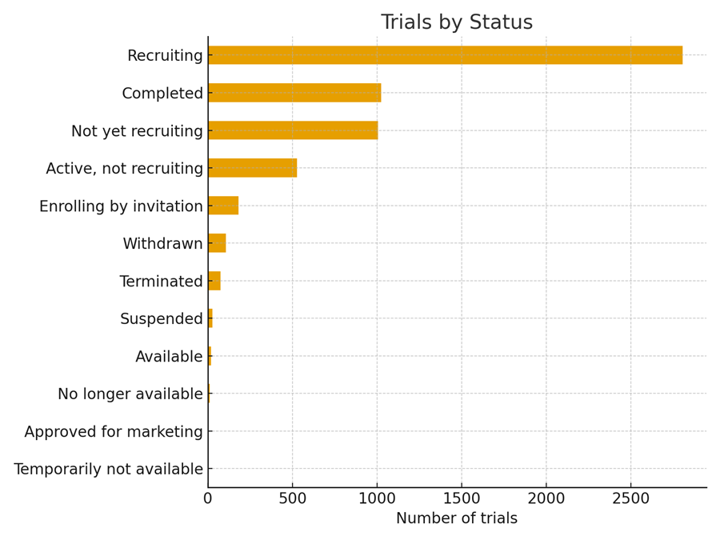

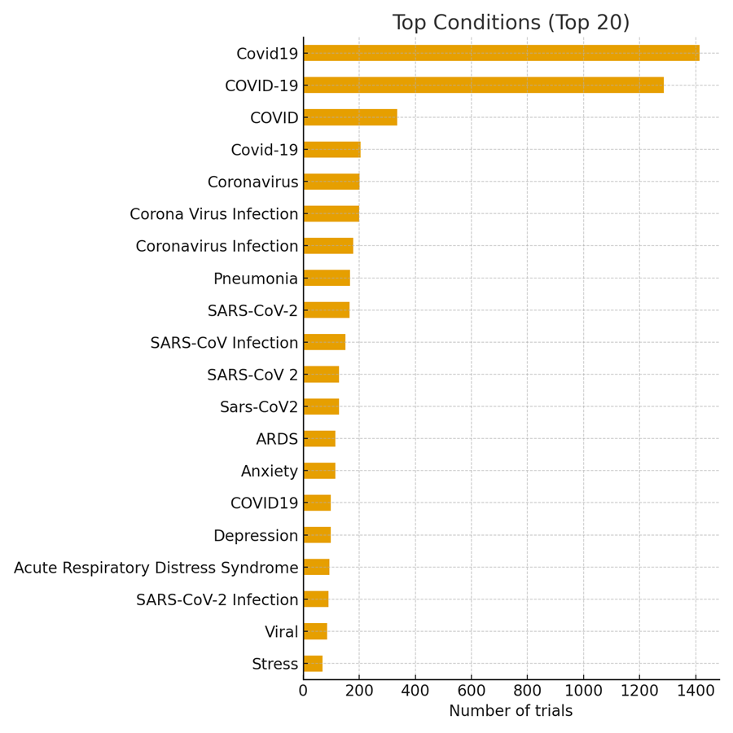

📜 Author
Project by: Pranjal Waghmare
Date: November 2025

